**Course: C339 Data Fundamentals**

**Date: March 1, 2023**

**Title: Optimisation and Logarithmic Time Complexity**

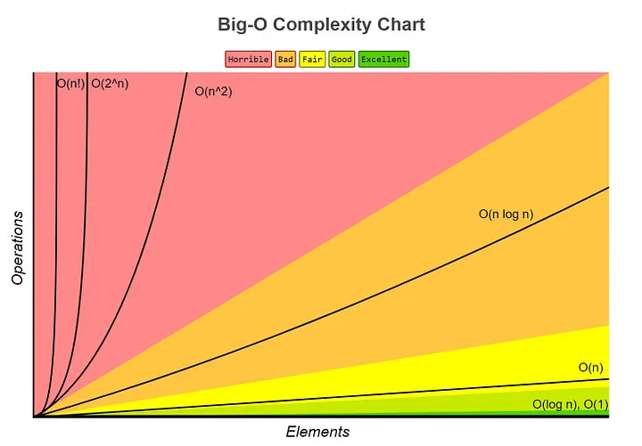

log(n) increases only by a tiny amount as N increases. When N doubles, log(n) only increases by 1.

Logarithmic time complexity log(n): Represented in Big O notation as O(log n), when an algorithm has O(log n) running time, it means that as the input size grows, the number of operations grows very slowly.